Trolls
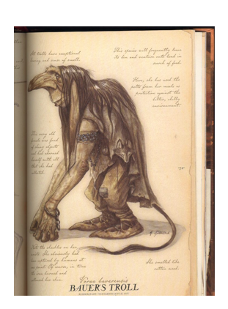
There are many different types of Troll. They are all related to Ogres, but less cunning then them. Even so, they are extremely dangerous. This picture shows a Bauer Troll which is female and comes from the north.

Where do they Live?
Bauer trolls live in or near freshwater and usually make their homes in nests of rushes and mud along the banks of a bog or deep river. Bridges are also good places to build beneath as they provide shade even in the winter months.

Appearance
Trolls have very long ears and big noses. Thus, they have excellent senses of smell and hearing. When Bauer Trolls are submerged, the only visible parts of their bodies are usually their humps and the top of their heads, which look like grass covered rocks.
Trolls are quite agile in the water, but clumsy on dry land. To fix this problem, they balance themselves on their enormous knuckles. Their extremely long arms also help them reach out from under the water to catch any passing prey.

How Do they Behave?
Though they appear brutish, trolls can communicate in the local tongue and are skilled at word games. As a result, they may at first carry off humans so they can chat to them rather than eat them. However, it is important to remember that trolls are always starving and finding food to eat is their main purpose in life.

Trolls are constantly ravenous and their hunger means they enjoy devouring whole herds of cows and flocks of sheep. They especially enjoy eating sheep but will take whatever they can catch. They can survive extreme weather and therefore live as far as possible from human settlements. As sunlight turns them instantly to stone, they are nocturnal creatures. Trolls are more common in the north where it is dark for months at a time.

'
